GUÍA DE AUTOEVALUACIÓN DE UNIDAD 1 “HOME TIME”
Guía n° 5 English Language

Nombre: |  | Curso: | 5th | Fecha

INSTRUCCIONES:
- Cuenta con 5 días para responder la guía.
- No se podrá entregar la guía sin estar resuelta completamente.
- La guía puede ser resuelta con apoyo de un diccionario y sus cuadernos de ser necesario. No está permitido copiar trabajos de otros compañeros/as.
- Utilizar lápiz pasta azul o negro.
- LA GUÍA DEBE SER ENVIADA EL DÍA VIERNES 05 DE JUNIO HASTA LAS 16 HRS al correo:
- Pamela.roky@elar.cl
- Esta guía no lleva nota

Objetivos: Demostrar conocimiento sobre el uso del presente simple y vocabulario temático.
Contenidos: Presente simple en su forma afirmativa, negativa e interrogativa y verbos para la tercera persona singular y vocabulario sobre actividades de rutina diaria.

ITEM I.- Choose the correct alternative for each sentence below. Please! Read carefully before choosing your alternative. Remember! This content is about Present Simple with its different forms such as Affirmative, Negative, Interrogative and short answers.

- She ______________ her room.  - Clean  - Cleaning  - Cleans  - To clean | - We _____________ in the garden.  - Playing  - To play  - Play  - Plays
- I ___________ have lunch.  - Not do  - Don’t  - Doesn’t  - Not does | - He __________ work at the hospital.  - Don’t  - Not do  - Doesn’t  - Not does
- _______ they go to school on Sundays?  - Do  - Does  - Don’t  - Doesn’t | - ________ the cat drink milk?  - Doesn’t  - Do  - Does  - Don’t
- Do you obey your parents? Yes, I ________  - Don’t  - Doesn’t  - Does  - Do | - Does Peter play the piano? No, he _______  - Doesn’t  - Don’t  - Do  - Does
- The verb ‘fix’ for 3rd singular person is:  - Fixing  - Fixs  - Fixes  - To fix | - The verb ‘cry’ for 3rd singular person is:  - To cry  - Crying  - Crys  - Cries

ITEM II.- Look carefully the pictures below, and then, choose the correct alternative for each one. Remember! This vocabulary is related to daily routines.

- Do my homework  - Have breakfast  - Cook  - Wake up | 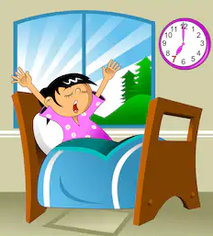 | 12)  a) Have a lunch  b) Brush my hair  c) Do my homework  d) Take a nap | 
13)  a) Get up  b) Ride my bike  c) Go to work  d) Do my homework | 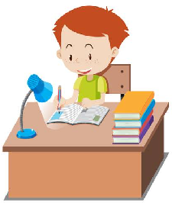 | 14)  a) Watch TV  b) Brush my teeth  c) Study  d) Drink | 
15)  a) Wake up  b) Read  c) Take the bus  d) Go to sleep | 